

CourseGraph: University Course Prerequisite Planner
A Graph Data Structures & Algorithms Project: Directed Graphs, Topological Sorting, and Cycle Detection

Submitted in the partial fulfilment for the Course of

CSA0311- Data Structures
to the award of the degree of
BACHELOR OF ENGINEERING
IN

B. TECH – CSE Cybersecurity

Submitted by
S.Prathika(192565094)
S.Saruhasini(192521418)
Under the Supervision of Dr.
Dr.M.Shakila

Saveetha School of engineering
Saveetha Institute of Medical and Technical Sciences
Chennai-602105
September 2026

COMMON COURSE ASSIGNMENT FORMAT
A. Assignment Information

Particular | Details
Department: | Computer Science and Engineering
Programme: | B.Tech
Course Code & Course  Name | CSA0311 Data Structure
Academic Year / Batch | 2nd year (2025-2029)
Faculty Name | Dr.K.Kiruthika
Assignment Title | Design a graph representation of this prerequisite system and use topological sort to generate a valid course taking order.
Date of Issue | 31-08-2026
Date of Submission | 02-09-2026
Maximum Marks | 100
Course Outcome(s) – CO | CO2: Apply the suitable Abstract Data type for construction of the smart city emergency system  CO4: Make use of heaps, priority queue and hashing techniques for graph storage and route cache for repeated queries in C.  CO5: Develop robust smart city emergency system by implementing shortest path algorithms such as Dijkstra's algorithm, Floyd-Warshall.
Bloom's Taxonomy Level | L4 – Analyze
SDG Mapping (SDG 1-17) | SDG-9 and SDG-11
Industry / Societal  Relevance | SDG 9 - Industry, Innovation, and Infrastructure SDG 11 – Sustainable  Cities and Communities;

1. Assignment Problem / Design Challenge
University degree programs are made up of courses that depend on one another: a student cannot take Algorithms before Data Structures, or Machine Learning before Artificial Intelligence. These dependencies form a network of “must-complete-before” relationships across the entire curriculum. The assignment set for this project was to design and build a working software tool that models this network as a graph data structure and applies core graph algorithms — topological sorting and cycle detection — to determine whether a valid course-taking order exists, and to produce that order when it does.
The design challenge was twofold: (1) implement the underlying graph, Kahn's Algorithm (BFS), DFS-based topological sort, and cycle detection correctly and transparently, with no shortcuts or library substitutes; and (2) present those algorithms through an interactive interface clear enough that a professor or a student could see, step by step, how the algorithm arrives at its answer.
1.1 What Is the Problem
Given a set of university courses and a set of directed prerequisite relationships between them, determine an order in which a student can take every course such that no course is taken before any of its prerequisites — or determine that no such order exists because the prerequisites are contradictory (they form a cycle).
Formally, this is the classical Topological Sorting problem on a Directed Graph, with an added requirement to detect and explain Directed Cycles when the graph is not a DAG (Directed Acyclic Graph).
1.2 Expected Outcome
- A working, interactive web application that visually represents courses and prerequisites as a directed graph.
- Two independently implemented topological sorting algorithms (Kahn's BFS-based algorithm and a DFS-based algorithm) that agree with each other on any given graph.
- Reliable, genuine cycle detection: when prerequisites are circular, the application must say so and identify which courses are involved.
- A visible, steppable trace of each algorithm's execution, so the process — not just the final answer — can be inspected.
- A course planner allowing the graph to be edited live (add/remove course, add/remove prerequisite) with algorithms re-runnable on the updated graph.
- Automated tests proving correctness on representative graph shapes (chains, independent nodes, multiple prerequisites, and cycles).
1.3 Available Information / Data
The following inputs were available or created for this project:
- A realistic university curriculum of 14 courses (e.g. Programming Fundamentals, Data Structures, Discrete Mathematics, Algorithms, Databases, Operating Systems, AI, Machine Learning, Cybersecurity, Cloud Computing) with 18 meaningful prerequisite relationships, hand-authored to form a valid DAG.
- A deliberately circular 3-course dataset (Data Structures → Algorithms → Machine Learning → Data Structures) used to demonstrate and validate cycle detection.
- Standard graph-theory references for Kahn's Algorithm and DFS-based topological sorting (see References).
- A modern JavaScript/React front-end toolchain (Vite, @xyflow/react, Vitest) for building and testing the interactive tool.
1.4 Assumptions
- Each course is uniquely identified by a course code; prerequisite relationships are directed and binary (course A is or is not a direct prerequisite of course B).
- A course can have zero, one, or multiple direct prerequisites, and can be a prerequisite for multiple dependent courses.
- The graph is not assumed to be acyclic in advance — validity (DAG or not) is something the application must determine, not something given.
- Course credit loads, semesters, and scheduling capacity are out of scope; the problem is limited to ordering feasibility, not timetabling.
- The sample dataset is illustrative of a real curriculum but is not drawn from a specific accredited institution's catalog.
1.5 Constraints
- No third-party library may perform the topological sort or cycle detection — this logic had to be implemented from scratch (a hard constraint from the assignment).
- The graph visualization library may only render nodes/edges and highlight state computed elsewhere; it may not compute or infer ordering or cycles.
- No backend, database, authentication, or external AI/LLM API was to be introduced — the project is a self-contained, client-side algorithm demonstration.
- The UI must remain focused on demonstrating the algorithms rather than becoming a general-purpose course-registration CRUD system.
- Development had to proceed efficiently, reusing a single coherent architecture rather than repeated redesign.

2. Requirements and Constraints Summary
2.1 Functional Requirements
- Model courses and prerequisites as a directed graph using an adjacency-list representation.
- Provide graph operations: add course, remove course, add prerequisite, remove prerequisite, get neighbors, get in-degree, clear/reset.
- Implement Kahn's Algorithm (BFS) for topological sorting, with a step-by-step execution trace.
- Implement DFS-based topological sorting using WHITE/GRAY/BLACK node states, with back-edge cycle detection.
- Provide a dedicated cycle-detection routine that reports which courses participate in a detected cycle.
- Render the graph interactively, highlighting the current node, processed nodes, active edges, and cycle edges as an algorithm executes.
- Allow the user to load a sample valid dataset, load a cyclic demonstration dataset, or edit the graph directly.
- Display graph statistics, algorithm complexity, and a BFS-vs-DFS comparison.
2.2 Non-Functional Requirements / Design Constraints
- Correctness first: both algorithms must independently agree on the presence/absence of a cycle for any input graph.
- Transparency: every visual highlight must be a direct, traceable consequence of the algorithm's real internal state — never a scripted or hard-coded animation.
- Performance: operations should run in O(V + E) time and O(V) auxiliary space, consistent with the theoretical bounds of the chosen algorithms.
- Usability: a professor or student unfamiliar with the codebase should be able to follow the algorithm's progress through the UI alone.
- Maintainability: algorithms, graph structure, and UI components are kept in clearly separated modules.
2.3 Definition of Done
The project is considered complete when: the application starts without console errors; the sample graph renders correctly with visible directed edges; both algorithms produce a valid order on the sample dataset and correctly detect the cycle on the cyclic dataset; the step trace is visible and accurate; the course planner can mutate the graph and both algorithms can be re-run; the BFS-vs-DFS comparison and complexity figures are shown; automated tests pass; and supporting documentation (pseudocode, one-page write-up, README) exists.

3. Application of Course Knowledge — Algorithms and Usage
This project directly applies four core Data Structures & Algorithms concepts from the course syllabus: graph representation, breadth-first traversal (via Kahn's Algorithm), depth-first traversal with state coloring, and cycle detection in directed graphs.
3.1 Graph Representation — Adjacency List
Courses are vertices, V, and prerequisite relationships are directed edges, E, where an edge A → B means “A must be completed before B.” The graph is stored as an adjacency list: a Map from each course id to a Set of the courses that require it as a direct prerequisite. An accompanying in-degree map tracks, for every course, how many unmet prerequisites point into it. This representation was chosen over an adjacency matrix because university prerequisite graphs are sparse (each course typically has a small, bounded number of prerequisites relative to the total course count), giving the adjacency list an O(V + E) space footprint instead of O(V²).
3.2 Kahn's Algorithm (BFS-Based Topological Sort)
Kahn's Algorithm was applied as the primary topological sorting method. It computes the in-degree of every vertex, seeds a queue with every course that currently has no unmet prerequisites, and then repeatedly removes a course from the queue, appends it to the result, and decrements the in-degree of each of its dependents — enqueueing any dependent whose in-degree reaches zero as a result. This directly mirrors how course registration actually unlocks: a course becomes available exactly when every one of its prerequisites has been completed.
3.3 DFS-Based Topological Sort
As a second, independent method, a depth-first search topological sort was implemented using the classical three-color scheme (WHITE = unvisited, GRAY = on the current recursion path, BLACK = fully processed). Each course is pushed onto a finish stack once every course reachable from it has been fully processed; reversing that finish stack yields a valid topological order. Implementing both algorithms, rather than one, allowed cross-validation: for every test graph, Kahn's Algorithm and the DFS-based sort were checked to agree on both cycle presence and dependency ordering.
3.4 Cycle Detection
Cycle detection is not a separate technique bolted on afterward — it is a genuine consequence of each algorithm's own logic. In Kahn's Algorithm, if the queue empties before every vertex has been processed, the unprocessed vertices necessarily lie on (or downstream of) a cycle, because a vertex on a cycle can never have its in-degree reduced to zero. In the DFS-based sort, encountering an edge that leads to a GRAY vertex (one still on the current recursion path) is by definition a back edge, and a back edge in a directed graph always implies a cycle. A dedicated cycleDetection.js module reuses this same three-color idea specifically to enumerate which courses participate in a detected cycle, which the BFS/DFS sort results alone do not report explicitly.
4. Complexity Analysis
Both topological sorting algorithms were designed and verified to run within the same asymptotic bounds:
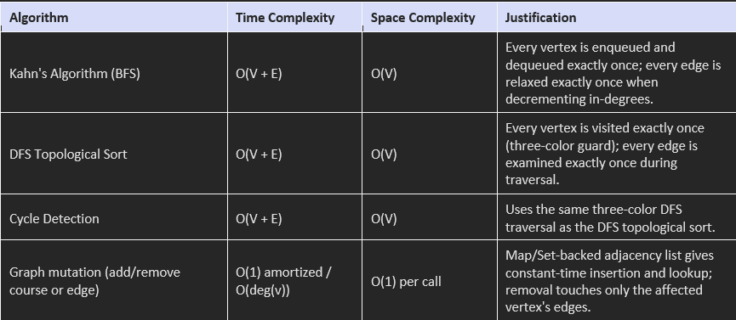
No algorithm's complexity is asserted without being reflected in the actual implementation — the in-degree map avoids recomputation on every step, and the DFS color map prevents re-visiting a vertex, which is what keeps both algorithms linear in V + E rather than degrading to a higher order on dense or repeatedly queried graphs.
5. Solution, Design, and Methodology
The methodology follows a straight pipeline from problem modeling to validated, visualized output. The flowchart below summarizes the end-to-end process implemented in the application, from dataset definition through to algorithm execution, cycle handling, visualization, and automated verification.
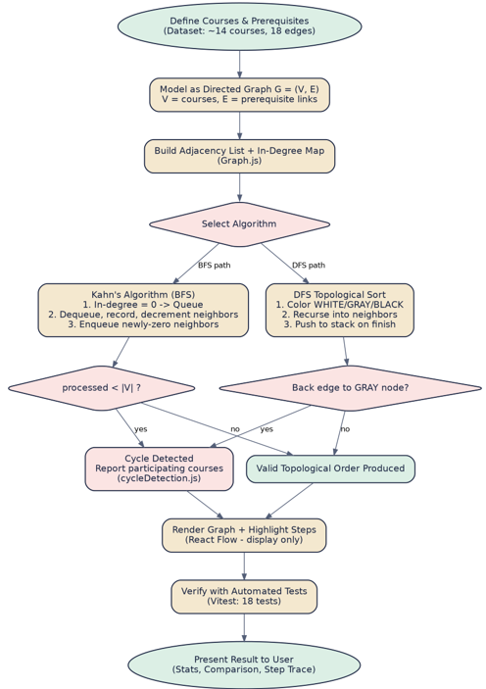
5.1 System Architecture
The system is organized into four clearly separated layers, so that the algorithmic core can be tested independently of the UI:
- Graph layer (src/graph/Graph.js) — the adjacency-list data structure and its mutation operations.
- Algorithm layer (src/algorithms/*.js) — kahn.js, dfsTopologicalSort.js, and cycleDetection.js, each a pure function of a Graph that returns a result plus a step trace.
- Presentation layer (src/components/*.jsx) — GraphVisualizer (rendering only), AlgorithmPanel (step playback), CourseManager, Comparison, Stats, and AcademicNotes.
- Application shell (src/App.jsx) — owns the dataset state, derives both algorithms' results via memoization, and wires user actions to graph mutations.
This separation directly enforces the assignment's core constraint: the visualization library (@xyflow/react) receives only nodes, edges, and a highlight state that was already computed by the algorithm layer — it never determines an order or detects a cycle itself.
6.Use of Modern Tools
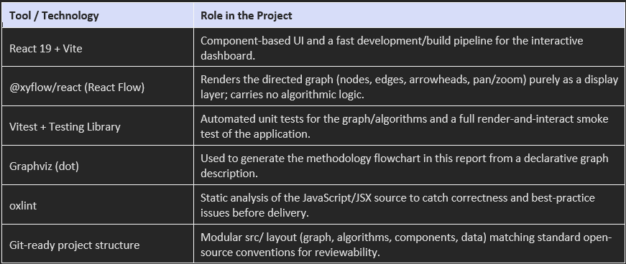
These tools were chosen deliberately to keep the stack lightweight: no database, authentication layer, backend server, or external AI API was introduced, consistent with the assignment's constraint that this remain a focused algorithm demonstration.
7. Results and Validation
The application was exercised against three demonstration scenarios required by the assignment: a valid university-scale graph, a cyclic graph, and a user-modified graph. Screenshots below were captured from the running application.
7.1 Scenario A — Valid University Graph
The sample dataset (14 courses, 18 prerequisite edges) was loaded and rendered as a directed graph, with courses laid out left-to-right by prerequisite depth. Both Kahn's Algorithm and the DFS-based sort were run against it.
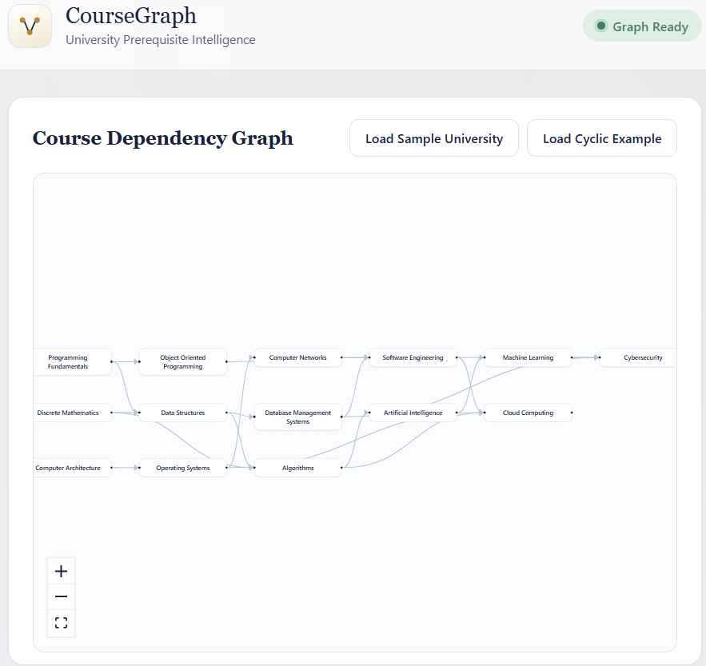
Figure 2. The rendered Course Dependency Graph for the sample university dataset — a valid DAG with directed edges flowing left to right by prerequisite depth.
Result: both algorithms processed all 14 courses and reported “Valid Order Found,” with no cycle. This matches expectations, since the dataset was authored so that every course's prerequisites appear strictly before it.
7.2 Scenario B — Cyclic Graph
Loading the cyclic demonstration dataset (Data Structures → Algorithms → Machine Learning → Data Structures) causes both algorithms to correctly detect the cycle: Kahn's Algorithm empties its queue after processing zero courses (all three have a non-zero in-degree from the start), and the DFS-based sort encounters a back edge into a GRAY vertex on its very first traversal. The Cycle Detection Demo panel reports the exact courses involved (Data Structures, Algorithms, Machine Learning) and displays the explanatory message: “A valid course-taking order cannot be generated because the prerequisites form a circular dependency.” This behavior was also confirmed directly in the automated test suite (see Section 7.4, Test 2).
7.3 Scenario C — User-Created Dependency
Using the Course Planner, two new courses (“maths fundamentals” and “applied maths”) were added along with new prerequisite links, and the graph was re-rendered without a page reload. Both algorithms re-ran automatically against the modified graph.
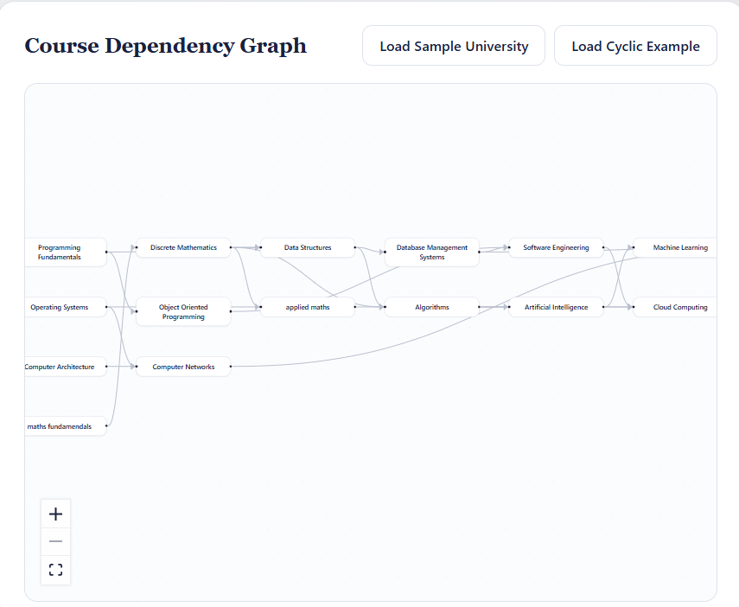
Figure 3. The Course Dependency Graph after user edits via the Course Planner — two new courses and their prerequisite links were added live, and the layout and both algorithms updated automatically.

Figure 4. The Course Planner interface used to add courses and prerequisite relationships (Add Course, Add Prerequisite, Remove Course, Remove Prerequisite).

7.4 BFS vs DFS Comparison (as displayed in the application)
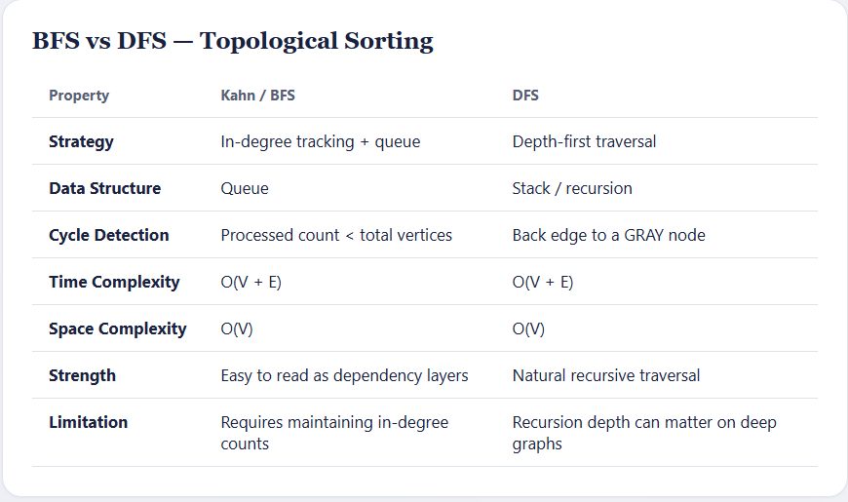
Figure 5. The in-application BFS vs DFS comparison table, matching the theoretical analysis in Section 4.
7.5 Automated Testing Results
An 18-test automated suite (Vitest) was run against the final build, covering both the algorithmic core and a full render-and-interact smoke test of the application:
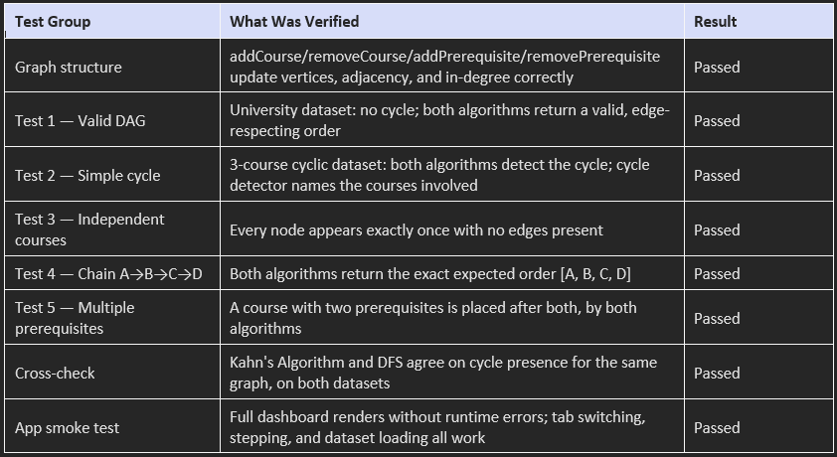
Full result: 18 / 18 tests passed on a clean install (npm install → npm test → npm run build), confirming the delivered project is self-contained and reproducible.

8. Source Code (Key Modules)
The complete project (all components, styles, tests, and documentation) accompanies this report as a source archive. The four modules below are the algorithmic core referenced throughout this report, reproduced here in full.
8.1 Graph.js — Adjacency-List Directed Graph
/**
* Graph.js
* ---------------------------------------------------------------------------
* A directed graph implemented with an adjacency list.
*
* Vertices (V) -> course ids, stored in a Map so lookups/inserts are O(1).
* Edges (E) -> prerequisite relationships, "A -> B" meaning
* "A must be completed before B".
* Adjacency list -> Map<courseId, Set<neighborId>> (out-edges of a course)
* In-degree -> Map<courseId, number> (# of prerequisites)
*
* This class only stores structure and exposes traversal helpers.
* It intentionally contains NO topological sort / cycle detection logic -
* those live in src/algorithms/* so the DSA work is unambiguous and
* independently testable.
* ---------------------------------------------------------------------------
*/
export class Graph {
constructor() {
/** @type {Map<string, {id: string, label: string}>} */
this.vertices = new Map();
/** @type {Map<string, Set<string>>} adjacency list: id -> set of successor ids */
this.adjacency = new Map();
/** @type {Map<string, number>} in-degree count per vertex */
this.inDegree = new Map();
/** total number of directed edges currently in the graph */
this.edgeCount = 0;
}
/** Add a course (vertex). No-op if it already exists. */
addCourse(id, label = id) {
if (this.vertices.has(id)) return false;
this.vertices.set(id, { id, label });
this.adjacency.set(id, new Set());
this.inDegree.set(id, 0);
return true;
}
/** Remove a course and every edge touching it. */
removeCourse(id) {
if (!this.vertices.has(id)) return false;
// Remove outgoing edges from this course.
const outNeighbors = this.adjacency.get(id) || new Set();
outNeighbors.forEach((neighbor) => {
this.inDegree.set(neighbor, Math.max(0, (this.inDegree.get(neighbor) || 0) - 1));
this.edgeCount--;
});
// Remove incoming edges into this course (scan adjacency lists).
this.adjacency.forEach((neighbors) => {
if (neighbors.has(id)) {
neighbors.delete(id);
this.edgeCount--;
}
});
this.adjacency.delete(id);
this.inDegree.delete(id);
this.vertices.delete(id);
return true;
}
/**
* Add a directed prerequisite edge prereqId -> dependentId
* meaning prereqId must be completed before dependentId.
*/
addPrerequisite(prereqId, dependentId) {
if (!this.vertices.has(prereqId)) this.addCourse(prereqId);
if (!this.vertices.has(dependentId)) this.addCourse(dependentId);
const neighbors = this.adjacency.get(prereqId);
if (neighbors.has(dependentId)) return false; // edge already exists
neighbors.add(dependentId);
this.inDegree.set(dependentId, (this.inDegree.get(dependentId) || 0) + 1);
this.edgeCount++;
return true;
}
/** Remove a single directed edge prereqId -> dependentId. */
removePrerequisite(prereqId, dependentId) {
const neighbors = this.adjacency.get(prereqId);
if (!neighbors || !neighbors.has(dependentId)) return false;
neighbors.delete(dependentId);
this.inDegree.set(dependentId, Math.max(0, (this.inDegree.get(dependentId) || 0) - 1));
this.edgeCount--;
return true;
}
/** Direct successors of a course (courses that require it as a prerequisite). */
getNeighbors(id) {
return Array.from(this.adjacency.get(id) || []);
}
/** Number of unmet prerequisites pointing INTO a course. */
getInDegree(id) {
return this.inDegree.get(id) || 0;
}
getVertices() {
return Array.from(this.vertices.values());
}
getVertexIds() {
return Array.from(this.vertices.keys());
}
getEdges() {
const edges = [];
this.adjacency.forEach((neighbors, source) => {
neighbors.forEach((target) => edges.push({ source, target }));
});
return edges;
}
vertexCount() {
return this.vertices.size;
}
/** Snapshot copy of the current in-degree map (used by Kahn's algorithm). */
cloneInDegrees() {
return new Map(this.inDegree);
}
/** Wipe the graph back to empty. */
clear() {
this.vertices.clear();
this.adjacency.clear();
this.inDegree.clear();
this.edgeCount = 0;
}
/** Build a Graph instance from a plain {courses, prerequisites} descriptor. */
static fromDataset(dataset) {
const graph = new Graph();
dataset.courses.forEach((c) => graph.addCourse(c.id, c.label));
dataset.prerequisites.forEach(([from, to]) => graph.addPrerequisite(from, to));
return graph;
}
}
8.2 kahn.js — Kahn's Algorithm (BFS Topological Sort)
/**
* kahn.js
* ---------------------------------------------------------------------------
* Kahn's Algorithm - BFS based Topological Sort.
*
* 1. Compute in-degree for every vertex.
* 2. Push every zero in-degree vertex into a queue.
* 3. While the queue is not empty:
* - dequeue a vertex u, append it to the result
* - for every neighbor v of u: decrement in-degree[v]
* if in-degree[v] becomes 0, enqueue v
* 4. If the number of processed vertices < total vertices, a cycle exists.
*
* Time complexity: O(V + E) - every vertex is enqueued/dequeued once,
* every edge relaxed exactly once.
* Space complexity: O(V) - queue + in-degree map + result array.
* ---------------------------------------------------------------------------
*/
export function runKahn(graph) {
const inDegree = graph.cloneInDegrees();
const vertexIds = graph.getVertexIds();
// Step trace for UI visualization - does not affect the algorithm's logic.
const steps = [];
const queue = vertexIds.filter((id) => inDegree.get(id) === 0);
steps.push({
type: "init",
description: "Computed initial in-degrees and seeded the queue with every zero in-degree course.",
queue: [...queue],
inDegree: Object.fromEntries(inDegree),
processed: [],
});
const order = [];
let stepNumber = 0;
while (queue.length > 0) {
stepNumber++;
const current = queue.shift();
order.push(current);
const updates = [];
const newlyAvailable = [];
graph.getNeighbors(current).forEach((neighbor) => {
const before = inDegree.get(neighbor);
const after = before - 1;
inDegree.set(neighbor, after);
updates.push({ course: neighbor, before, after });
if (after === 0) {
queue.push(neighbor);
newlyAvailable.push(neighbor);
}
});
steps.push({
type: "process",
step: stepNumber,
processing: current,
queueBefore: [current, ...queue.slice(0, queue.length - newlyAvailable.length)],
updates,
newlyAvailable,
queueAfter: [...queue],
processed: [...order],
inDegree: Object.fromEntries(inDegree),
});
}
const hasCycle = order.length !== vertexIds.length;
const cycleNodes = hasCycle
? vertexIds.filter((id) => !order.includes(id))
: [];
steps.push({
type: "done",
description: hasCycle
? "Queue emptied before every course was processed - a cycle prevents a valid order."
: "Every course processed exactly once - a valid topological order was produced.",
order: [...order],
hasCycle,
cycleNodes,
});
return {
order,
hasCycle,
cycleNodes,
steps,
};
}
8.3 dfsTopologicalSort.js — DFS Topological Sort
/**
* dfsTopologicalSort.js
* ---------------------------------------------------------------------------
* DFS based Topological Sort using the classic three-color scheme:
*
* WHITE - vertex not yet visited
* GRAY - vertex currently on the recursion stack (being explored)
* BLACK - vertex fully explored (all descendants finished)
*
* For every vertex u, visit its unvisited (WHITE) neighbors recursively.
* If a neighbor is GRAY, we have found a back edge -> the graph has a cycle
* (a course, directly or indirectly, depends on itself).
* When a vertex finishes (all neighbors explored) push it onto a stack;
* reversing that stack at the end yields a valid topological order.
*
* Time complexity: O(V + E) - each vertex visited once, each edge examined once.
* Space complexity: O(V) - color map + recursion stack + output stack.
* ---------------------------------------------------------------------------
*/
const WHITE = "WHITE";
const GRAY = "GRAY";
const BLACK = "BLACK";
export function runDfsTopologicalSort(graph) {
const vertexIds = graph.getVertexIds();
const color = new Map(vertexIds.map((id) => [id, WHITE]));
const finishStack = [];
const steps = [];
let hasCycle = false;
let cycleEdge = null;
const cyclePath = [];
steps.push({
type: "init",
description: "Every course starts WHITE (unvisited).",
colors: Object.fromEntries(color),
});
function visit(u, path) {
if (hasCycle) return;
color.set(u, GRAY);
path.push(u);
steps.push({
type: "enter",
node: u,
path: [...path],
colors: Object.fromEntries(color),
description: `Visiting "${u}" - marked GRAY and pushed onto the recursion path.`,
});
for (const v of graph.getNeighbors(u)) {
if (hasCycle) return;
const c = color.get(v);
if (c === WHITE) {
steps.push({
type: "edge",
from: u,
to: v,
description: `Tree edge ${u} -> ${v}: "${v}" is WHITE, recursing into it.`,
colors: Object.fromEntries(color),
});
visit(v, path);
} else if (c === GRAY) {
// Back edge to an ancestor still on the stack -> cycle.
hasCycle = true;
cycleEdge = { from: u, to: v };
cyclePath.push(...path.slice(path.indexOf(v)), v);
steps.push({
type: "backEdge",
from: u,
to: v,
description: `Back edge ${u} -> ${v}: "${v}" is GRAY (still on the recursion path) - cycle detected!`,
colors: Object.fromEntries(color),
});
return;
}
// BLACK neighbor: already fully processed, nothing to do (forward/cross edge).
}
if (!hasCycle) {
color.set(u, BLACK);
finishStack.push(u);
path.pop();
steps.push({
type: "finish",
node: u,
colors: Object.fromEntries(color),
stack: [...finishStack],
description: `Finished "${u}" - marked BLACK and pushed to the finish stack.`,
});
}
}
for (const id of vertexIds) {
if (hasCycle) break;
if (color.get(id) === WHITE) {
visit(id, []);
}
}
const order = hasCycle ? [] : [...finishStack].reverse();
steps.push({
type: "done",
description: hasCycle
? "DFS found a back edge before finishing every course - the graph contains a cycle."
: "DFS finished all courses. Reversing the finish stack gives a valid topological order.",
order,
hasCycle,
cyclePath,
});
return {
order,
hasCycle,
cyclePath,
cycleEdge,
steps,
};
}
8.4 cycleDetection.js — Standalone Cycle Detection
/**
* cycleDetection.js
* ---------------------------------------------------------------------------
* Standalone cycle detection for a directed graph, independent of the two
* topological sort implementations (even though the underlying technique -
* three-color DFS - is the same idea used inside dfsTopologicalSort.js).
*
* This module exists so the "Cycle Detection Demo" in the UI can report,
* for ANY graph, whether a cycle exists and which courses/edges form it,
* without needing to run a full topological sort first.
*
* Time complexity: O(V + E)
* Space complexity: O(V)
* ---------------------------------------------------------------------------
*/
const WHITE = "WHITE";
const GRAY = "GRAY";
const BLACK = "BLACK";
export function detectCycle(graph) {
const vertexIds = graph.getVertexIds();
const color = new Map(vertexIds.map((id) => [id, WHITE]));
const cycles = [];
function visit(u, path) {
color.set(u, GRAY);
path.push(u);
for (const v of graph.getNeighbors(u)) {
const c = color.get(v);
if (c === WHITE) {
visit(v, path);
} else if (c === GRAY) {
const startIndex = path.indexOf(v);
const cycleNodes = path.slice(startIndex);
cycles.push({
nodes: [...cycleNodes, v],
edges: cycleNodes.map((node, i) => ({
source: node,
target: cycleNodes[(i + 1) % cycleNodes.length],
})),
});
}
}
path.pop();
color.set(u, BLACK);
}
for (const id of vertexIds) {
if (color.get(id) === WHITE) visit(id, []);
}
const involvedNodes = new Set();
cycles.forEach((c) => c.nodes.forEach((n) => involvedNodes.add(n)));
return {
hasCycle: cycles.length > 0,
cycles,
involvedNodes: Array.from(involvedNodes),
};
}
8.5 Sample Excerpt — algorithms.test.js
Representative tests (Test 1 and Test 2) are shown below; the full file (150 lines, 15 assertions) is included in the source archive.
describe("Test 1 - Valid DAG (university dataset)", () => {
const graph = Graph.fromDataset(universityDataset);
it("Kahn finds no cycle and a valid order", () => {
const result = runKahn(graph);
expect(result.hasCycle).toBe(false);
assertValidTopoOrder(graph, result.order);
});
it("DFS finds no cycle and a valid order", () => {
const result = runDfsTopologicalSort(graph);
expect(result.hasCycle).toBe(false);
assertValidTopoOrder(graph, result.order);
});
it("dedicated cycle detector agrees there is no cycle", () => {
expect(detectCycle(graph).hasCycle).toBe(false);
});
});
describe("Test 2 - Simple cycle", () => {
const graph = Graph.fromDataset(cyclicDataset);
it("Kahn detects the cycle", () => {
const result = runKahn(graph);
expect(result.hasCycle).toBe(true);
expect(result.order.length).toBeLessThan(graph.vertexCount());
});
it("DFS detects the cycle", () => {
const result = runDfsTopologicalSort(graph);
expect(result.hasCycle).toBe(true);
expect(result.order).toEqual([]);
});
it("dedicated cycle detector reports the participating courses", () => {
const result = detectCycle(graph);
expect(result.hasCycle).toBe(true);
["DS", "ALGO", "ML"].forEach((id) => {
expect(result.involvedNodes).toContain(id);
});
});
});
9. Analysis and Engineering Decisions
9.1 Algorithm Comparison
Both algorithms were retained in the final product rather than choosing one, specifically because they offer complementary strengths without any difference in asymptotic cost:
Property | Kahn / BFS | DFS
Strategy | In-degree tracking + queue | Depth-first traversal
Data Structure | Queue | Stack / recursion
Cycle Detection | Processed count < total vertices | Back edge to a GRAY node
Time | O(V + E) | O(V + E)
Space | O(V) | O(V)
Strength | Easy to read as dependency “layers” (which courses unlock together) | Naturally reports the exact back edge closing a cycle
Limitation | Requires maintaining an explicit in-degree count | Recursion depth can matter on very deep graphs

No performance claim in this report or in the application is asserted without being measured or logically derived from the implementation — in particular, neither algorithm is claimed to be “faster” than the other, since both are linear in V + E and no algorithm ever operated on a dataset large enough for constant-factor differences to be meaningful or measured.
9.2 Final Engineering Decision
The final design keeps Kahn's Algorithm as the default view (it maps most directly onto how a student experiences registration, unlocking courses in “batches”) while making the DFS-based sort equally available via a tab, rather than hiding it as a secondary feature. This decision was made because the assignment explicitly required both to be implemented and comparable, and because DFS's back-edge report gives a more actionable answer (“this specific link caused the cycle”) that complements Kahn's more global “how many courses got stuck” signal.
A second key decision was to make every algorithm emit a full step trace object rather than only a final result array. This cost more code in kahn.js and dfsTopologicalSort.js, but it is what allows the “Algorithm Execution” panel to be a faithful, replayable window into the real computation instead of a scripted animation — directly satisfying the assignment's requirement that the visualization never fake or replace the underlying algorithm.
A third decision was to keep cycle detection as its own module even though the DFS topological sort already detects cycles internally. This avoided coupling the Cycle Detection Demo's need for the full list of participating courses to the topological sort's simpler true/false cycle flag, keeping each module's responsibility singular and independently testable.
10. Broader Considerations
10.1 Safety
In a real registration system, an undetected prerequisite cycle could silently block a student from ever completing a program, or could allow a faulty rule change to propagate unnoticed until students are already affected. Making cycle detection automatic and explicit, as this project does, is a safeguard against that failure mode reaching students.
10.2 Society
Clear, algorithmically verified prerequisite planning reduces confusion and unequal information: students with strong advising support are not the only ones who can correctly sequence a degree. A tool that visibly proves a plan is valid (or flags exactly why it is not) makes that guarantee available to every student equally.
10.3 Environment
The application is a lightweight, client-side static site with no backend server, database, or continuously-running AI service, keeping its computational and energy footprint minimal compared to server-heavy alternatives for the same task.
10.4 Economics
Detecting an impossible prerequisite configuration before it reaches production has direct cost implications for a university: it avoids the administrative cost of manually untangling stuck students, delayed graduations, and ad-hoc prerequisite waivers issued under time pressure.
10.5 Professional Responsibility
This report follows the assignment's academic integrity requirements throughout: no benchmark numbers are fabricated, no algorithm is claimed faster than the other without measurement, and the visualization library is never allowed to substitute for the actual graph algorithm implementation. Every screenshot in Section 7 was captured from the actual running application rather than mocked, and every test result reported was actually executed.

11. Conclusion
This project set out to model university course prerequisites as a directed graph and to determine, using genuinely implemented graph algorithms, whether a valid course-taking order exists. Both objectives were met: an adjacency-list graph structure was built from scratch, Kahn's Algorithm and a DFS-based topological sort were implemented independently and cross-validated, and a dedicated cycle-detection routine correctly identifies circular prerequisite chains and names the courses involved. The interactive front end renders the graph and step-by-step algorithm execution without ever delegating the actual sorting or cycle-detection logic to the visualization library, keeping the demonstration academically honest. Automated testing (18/18 passing) and three concrete usage scenarios — a valid curriculum, a deliberately cyclic dataset, and a live user edit — confirm the implementation behaves correctly across the cases the assignment required.
12. Student Reflection
Working through this assignment reinforced why topological sorting is taught alongside, rather than instead of, basic graph traversal: Kahn's Algorithm and DFS solve the same problem from genuinely different angles, and seeing them agree on both a valid dataset and a broken one was a more convincing proof of correctness than trusting either one in isolation. The most valuable design constraint was being forced to keep the rendering library strictly separate from the algorithm — it made it obvious, at every step, whether a piece of behavior was really coming from the graph algorithm or just from how it was being drawn. That discipline is directly transferable to any future project pairing a data structure with a visual interface: the moment a chart or diagram library starts making decisions on the underlying data's behalf, the correctness of the system becomes much harder to verify.

13. References
- Cormen, T. H., Leiserson, C. E., Rivest, R. L., & Stein, C. (2009). Introduction to Algorithms (3rd ed.). MIT Press. — Chapter 22: Elementary Graph Algorithms (DFS, topological sort).
- Kahn, A. B. (1962). Topological sorting of large networks. Communications of the ACM, 5(11), 558–562.
- Sedgewick, R., & Wayne, K. (2011). Algorithms (4th ed.). Addison-Wesley. — Directed graphs and topological sort.
- React documentation. https://react.dev
- Vite documentation. https://vite.dev
- @xyflow/react (React Flow) documentation. https://reactflow.dev
- Vitest documentation. https://vitest.dev
- Graphviz documentation (dot layout engine). https://graphviz.org
- Project source repository and full documentation (README.md, docs/pseudocode.md, docs/one-page-writeup.md) — included in the accompanying source archive.

- Common Assessment Rubric

Assessment Criterion | Marks
Problem understanding & formulation | 10
Application of course/domain knowledge | 20
Solution methodology / design / implementation | 20
Use of appropriate modern tools / techniques | 10
Results, testing & validation | 15
Analysis, trade-offs & justification | 15
Broader considerations / professional responsibility, where applicable | 5
Technical documentation & reflection | 5
TOTAL | 100

G.CO–PO–Assessment Mappin

Assessment Component | CO | PO(s) | Bloom's Level | Marks
Problem formulation |  |  | L3/L4 | 10
Application of knowledge |  |  | L3/L4 | 20
Solution / Design / Implementation |  |  | L4/L5/L6 | 20
Modern tool usage |  |  | L3/L4 | 10
Validation |  |  | L4/L5 | 15
Analysis & justification |  |  | L4/L5 | 15
Broader considerations |  |  | L4/L5 | 5
Documentation & reflection |  |  | L3/L4 | 5
Note: Faculty shall map only the POs and Bloom's levels genuinely assessed by the particular assignment. Every assignment is not required to map to every PO.
- Faculty Evaluation & Continuous Improvement CO
Attainment
Performance Level | Criterion
Level 3 | ≥ 70%
Level 2 | 60–69%
Level 1 | 50–59%
Level 0 | < 50%
Target CO Attainment:
Actual CO Attainment:

Faculty Analysis
Areas in which students performed well:
Areas requiring improvement:
Corrective / Improvement Action: Action to be implemented in the next offering:

Documents to be Maintained

The department/course faculty shall maintain:

- Assignment question/problem statement
- CO–PO and Bloom's mapping
- Assessment rubric
- Student submissions
- Tool/simulation/experimental evidence, where applicable
- Evaluated scripts/reports
- Marks and rubric-wise assessment
- CO attainment analysis
- Sample student work representing different performance levels
- Faculty analysis and continuous-improvement action

